**Experiment No:** 07

**Experiment Name:** Introduction to CSS.

**Theory:** CSS (Cascading Style Sheets) is a language used to style and layout web pages. It controls the appearance of HTML elements, such as colors, fonts, spacing, and overall layout. By separating the content (HTML) from the design (CSS), developers can create visually appealing websites that are easier to maintain and update. CSS also allows for responsive designs, making web pages look good on different screen sizes and devices.

**There are 3 ways to use CSS with HTML: Inline CSS, Internal CSS, External CSS.**

1. **Inline CSS:** Inline CSS is applied directly to an HTML element using the style attribute.
2. **Internal CSS:** Internal CSS is defined within the <style> tag in the <head> section of the HTML document.
3. **External CSS:** External CSS is defined in a separate CSS file and linked to the HTML document using the <link> tag.

**Lab Task:** Create a simple HTML webpage with at least three parts. Each part should contain Heading, Paragraph, List of Items, etc.

Apply the following styling using CSS:

➔ Use the class selector and ID selector to style each part differently.

➔ Adjust the box model properties (margin, padding, etc.) for selected elements.

➔ Set different font-size for headings and paragraphs.

➔ Use font-weight and font-style to modify the appearance of specific text.

➔ Apply a background color to one or more elements.

**Source Code:**

<!DOCTYPE html>

<html>

  <head>

    <title>My Cooking Portfolio</title>

    <link rel="stylesheet" type="text/css" href="cook.css" />

  </head>

  <body>

    <div id="about" class="section">

      <center><img src="cap.jpeg" />

    <h1><i><font color="purple">SADIA HUMAIRA MAISHA</i></h1>

      </font>

   </center>

      <h2>About me</h2>

      <p>

Assalamu Alaikum! My name is Sadia Humaira Maisha and I am from Bangladesh. Cooking is a beloved hobby of mine.My fascination with food began in my mother's kitchen, where thetantalizing aromas and vibrant flavors sparked my culinary curiosity. I find immense joy in the creative process of cooking. From experimenting with flavors to

perfecting techniques, cooking is both a challenge and a form of relaxation for me. I particularly enjoy Italian and Asian cuisines, which allow me to explore a diverse range of ingredients and cooking methods.

</p>

</div>

<div id="signature-dishes" class="section">

<h2>Signature Dishes</h2>

 <p> My signature recipe is "Chicken Biriyani" and it's one of my favorite dish also. I love how it combines rich flavors and textures in one dish.I often cook it at home or try different variations when eating out.Whenever I have to cook it I have to cook it in very large quantity as everyone love it.Here I share the easy recipe of my signature dish "Chicken Biriyani".

      </p>

      <center>

        <img src="biriyani.jpeg" alt="Signature Dish 2" />

        <p><b>Chicken Biriyani</b></p>

      </center>

      <h4><u>Ingredients</u></h4>

      <li>2 tbsp sunflower oil</li>

      <li>1 large onion,chopped</li>

      <li>4 chicken breasts</li>

      <li>1 lemon juice only</li>

      <li>2 tsp garam masala</li>

      <li>1 tsp chilli powder</li>

      <li>2g (1 tsp) salt</li>

      <li>300g(10oz) basmati rice</li>

      <li>1 garlic clove, crushed</li>

      <li>2.5cm piece fresh ginger,grated</li>

      <li>850ml (1 1/2pints) hot chicken stock</li>

      <li>3 tbsp chopped fresh coriander.</li>

      <h4><u>Method</u></h4>

      <li>

        Heat the oil in a large saucepan over a low heat. Add the onion, cover and cook for 10 minutes until softened.

      </li>

      <li>

      Cut the chicken into bite-size pieces, tip into a bowl, and add the lemon juice, garam masala, chilli powder and salt. Stir well to coat.

      </li>

      <li>

        Rinse the rice several times in cold water, until the water runs clear.Add the garlic and ginger to the onion and cook for 2 minutes, then add the chicken pieces and cook for a further 2 minutes, stirring constantly.

      </li>

      <li>

       Add the rice and hot stock to the pan, stir well then bring to the boil.Cover with a tight-fitting lid, reduce the heat slightly and cook for 5 minutes. Turn off the heat and leave the pan for 10 minutes to allow the rice to finish cooking in the steam. Do not remove the lid. Stir through the coriander and serve immediately.

      </li>

    </div>

    <div id="skills" class="section">

      <h3>Culinary Skills</h3>

      <p> I am not professionally trained. While I took a couple of classes at a kitchen store over a decade ago, over the years I have learned several

        things.

      </p>

<p>1. My knife skills are adequate to good in several ways, they’ll never be exceptional or chef-level. Patience when working with knives is a requirement!

      </p>

      <p> 2. I think my seasoning taste is good I’m very good at finding good

        recipes. Let’s face it, there’s lots of garbage recipes online.

      </p>

      <h3><font color="darkred">Baking</font></h3>

      <p>

        Otherhand, baking is part of culinary arts and it's my favorite part of cooking.Though I am not a proffesional baker but I tried to bake cake,cup cakes or muffin's by taking recipes from online.Here I am share with you my perfect vanila cup cakes recipe which i made very first time.Though it taste very well as every one said.

      </p>

      <center>

        <img src="cup cake.jpeg" alt="culinary" />

        <p><b>Vanila Cup Cakes</b></p>

      </center>

      <h4><u>Ingredients</u></h4>

      <li>1 ½ cups (190g) all-purpose flour</li>

      <li>1 ½ teaspoons baking powder</li>

      <li>¼ teaspoon salt</li>

      <li>½ cup (115g) unsalted butter, softened</li>

      <li>1 cup (200g) granulated sugar</li>

      <li>2 large eggs</li>

      <li>2 teaspoons vanilla extract</li>

      <li>½ cup (120ml) whole milk</li>

      <h4><u>Instructions</u></h4>

      <li>

        Preheat your oven to 350°F (175°C). Line a 12-cup muffin pan with cupcake liners.

      </li>

      <li>

        Mix Dry Ingredients: In a medium bowl, whisk together the flour, baking powder, and salt.

      </li>

      <li>

        Cream Butter and Sugar: In a large bowl, beat the softened butter and sugar together until light and fluffy.

      </li>

      <li>

        Add Eggs and Vanilla: Beat in the eggs one at a time, then stir in the vanilla extract.

      </li>

      <li>

       Combine Wet and Dry Ingredients: Gradually add the flour mixture,

        alternating with the milk, beginning and ending with the flour mixture. Beat until just combined.

      </li>

      <li>

        Fill Cupcake Liners: Divide the batter evenly among the cupcake liners,filling each about two-thirds full.

      </li>

      <li>

        Bake: Bake in the preheated oven for 18-20 minutes, or until a toothpick inserted into the center of a cupcake comes out clean.

      </li>

      <li>

        Cool: Allow the cupcakes to cool in the pan for a few minutes before transferring them to a wire rack to cool completely.

      </li>

    </div>

    <div id="contact" class="section">

      <h3>Contact Me</h3>

      <p>

        As I love to cook and serve to people. If you need me to cook or serve for you then please contact with me.

      </p>

      <p>Email:maisha@gmail.com | Phone: +88 01601893887</p>

      <p>

        Follow me on <a href="https://instagram.com">Instagram</a>,

        <a href="https://twitter.com">Twitter</a>

      </p>

    </div>

  </body>

</html>

Inside cook.css:

body {

  background-color: #fdeff1;

}

.section {

  margin: 20px;

  padding: 15px;

  border: 1px;

  border-radius: 10px;

}

#about {

  background-color: #f7dbd0;

  font-size: 18px;

}

#signature-dishes {

  background-color: hwb(193 70% 5%);

  font-size: 16px;

}

#skills {

  background-color: rgb(240, 240, 183);

  font-size: 14px;

}

#contact {

  background-color: rgb(176, 243, 215);

  font-size: 14px;

}

h1 {

  font-size: 24px;

  font-weight: bold;

}

h2 {

  font-size: 22px;

  font-weight: bold;

}

h3 {

  font-size: 20px;

  font-weight: bold;

}

p {

  font-size: 16px;

  font-style: italic;

}

ul,

ol {

  margin: 10px 0;

  padding-left: 20px;

}

**Output:**

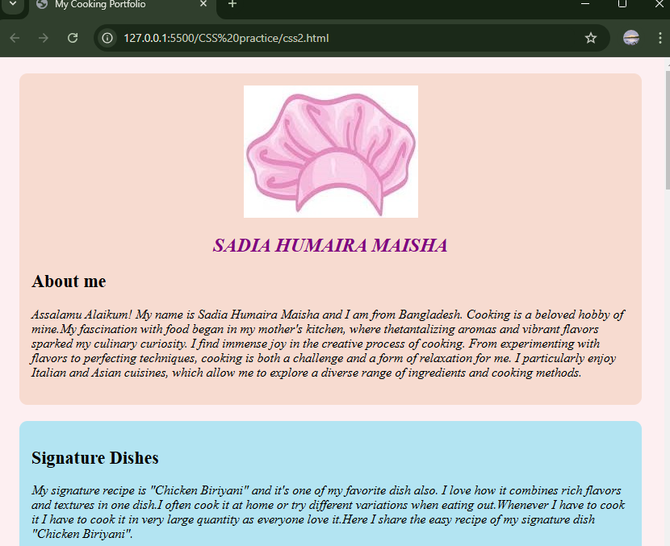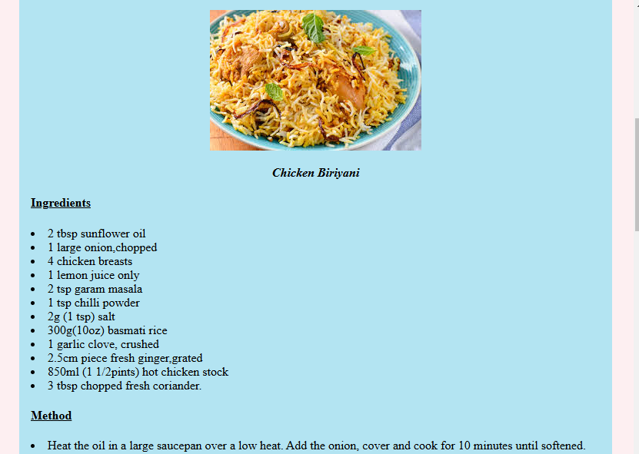

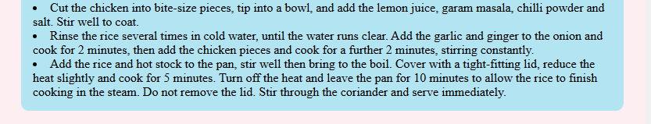

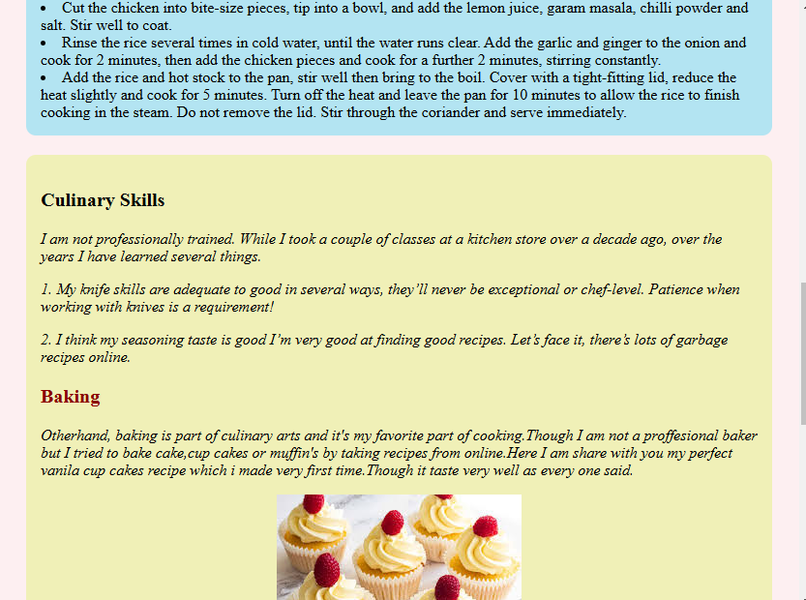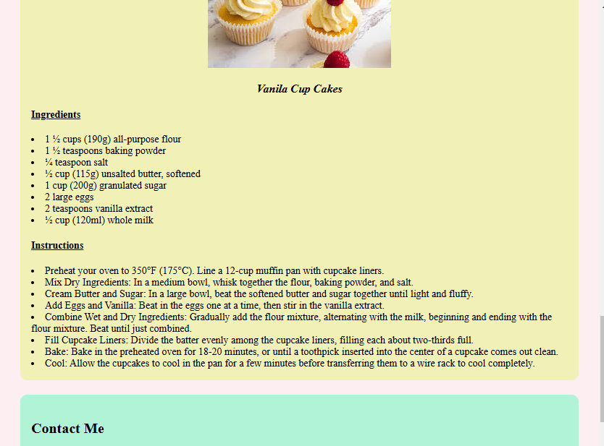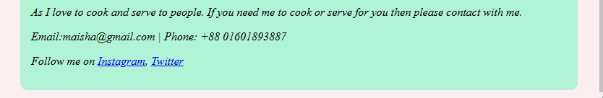

**Discussion:** In today’s lab, we got introduced with CSS.CSS (Cascading Style Sheets) is a language used to style and layout web pages. It controls the appearance of HTML elements, such as colors, fonts, spacing, and overall layout. By separating the content (HTML) from the design (CSS), developers can create visually appealing websites that are easier to maintain and update. CSS also allows for responsive designs, making web pages look good on different screen sizes and devices.By using class and id attributes ,we completed our lab task.